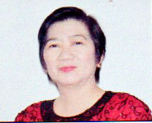

MESSAGE

My warmest congratulations to all graduates and completers of Grade 10 for the SY 2016-2017. My gratitude is also extended to our patient administrators, teachers and parents who have done their part in nurturing our children’s education.

Looking back, the school year came with challenges in all aspects of the educational system, however, much have been done and improved. We owe this from the parents and other stakeholders, who have shown their willingness to help the school and provide the necessary support, all for the welfare of the students as well as teachers and staff.

Likewise, the teachers, department heads and school head have shown their dedication by giving the students boundless opportunities to learn and improve themselves, thereby making them able to decide and make informed choices, deal with challenges, and aspire to achieve their dreams.

Truly all efforts are attuned with this year’s theme which is “Sabay–Sabay na Hakbang Tungo sa Maunlad na Kinabukasan!

Again, Congratulations and God Bless us all!

FROSERFINA J. BRAVO
OIC-Schools Division Superintendent

